End to End Data Analysis of Pizza Sales Using SQL

- #Retrieve the total number of orders placed.
- select sum(quantity) as "Total order" from order__details;
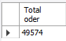
- #Calculate the total revenue generated from pizza sales.
- select sum(quantity*price)AS "revenue" from order_details o join pizzas p on o.pizza_id = p.pizza_id;
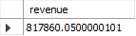
- #Identify the highest-priced pizza
- select max(size),max(price) from pizzas group by size;
- select size,max(price) from pizzas group by size order by max(price) DESC limit 1;
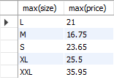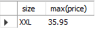
- #Identify the most common pizza size ordered.
- select size, sum(quantity) from pizzas p join order_details o on p.pizza_id = o.pizza_id group by size order by sum(quantity) DESC;
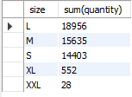

- #Determine the top 3 most ordered pizza types based on revenue.
- select price, category from pizzas a join pizza_types t on a.pizza_type_id = t.pizza_type_id order by price DESC limit 3;
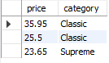
- ##Group the orders by date and calculate the average number of pizzas ordered per day
- select date,sum(quantity) from orders s join order__details a on s.order_id = a.order_id group by date;
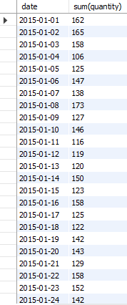

- #List the top 5 most ordered pizza types along with their quantities.
- select pizza_type_id, sum(quantity) from pizzas p join order_details o on o.pizza_id = p.pizza_id group by pizza_type_id order by sum(quantity) desc limit 5 ;

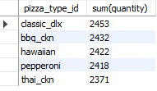
S

